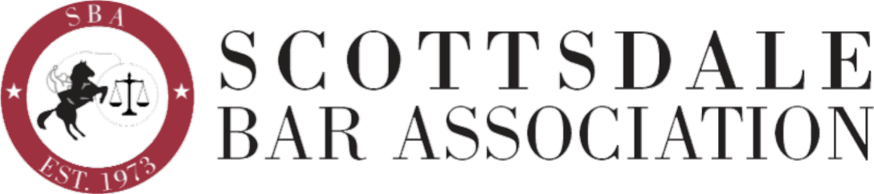

Email Sponsorship Order Form
Please spell sponsor name EXACTLY as you wish it to appear
Sponsor Name: Contact Name:
Contact Work Phone: Cell Phone: Contact Email:
Business Name:
Business Address: City: State: Zip+4:
Business Phone: Business Fax:
Email marketing option $500 Month of ____________________
What a Sponsor receives:
The association sends one e-mail in the selected month to our full e-mail list that features a message about the identified sponsor. This message, coming from the Scottsdale Bar Association, describes the sponsor’s product or service and includes a unique offer that is exclusive to our membership. The sponsor representative’s contact information is clearly communicated and our members are strongly encouraged to directly contact that person for more information or to schedule a meeting.

Specific months are assigned on a first request basis and may already be 'sold'. Attach a digital copy of your Email marketing offer/promotion (wording and any images) to this completed order form and return to the SBA.
A second email marketing option is available for an additional $350.
Your commitment to sponsor and your payment must be received ten (10) days prior
to the selected month in order for your sponsorship promotional material to be processed.

Please return completed form with your check, payable to Scottsdale Bar Association, to:
Perry L Goorman, 6624 East Aster Drive, Scottsdale, AZ 85254
{If payment by credit card is preferred, contact Alexis @ alexismerrittaz@yahoo.com for the form.}

For more information contact scottsdalebar@aol.com, or,
Perry at plgoorman@gmail.com, Wendy Anderson at wendy@wendyandersonlaw.com or David Schmidt at dschmidt@clarkhill.com

